**Class and Style Bindings**

<button [attr.disabled]=”true” class="btn btn-primary" (click)='toggleImage()'>

Show Image

</button>

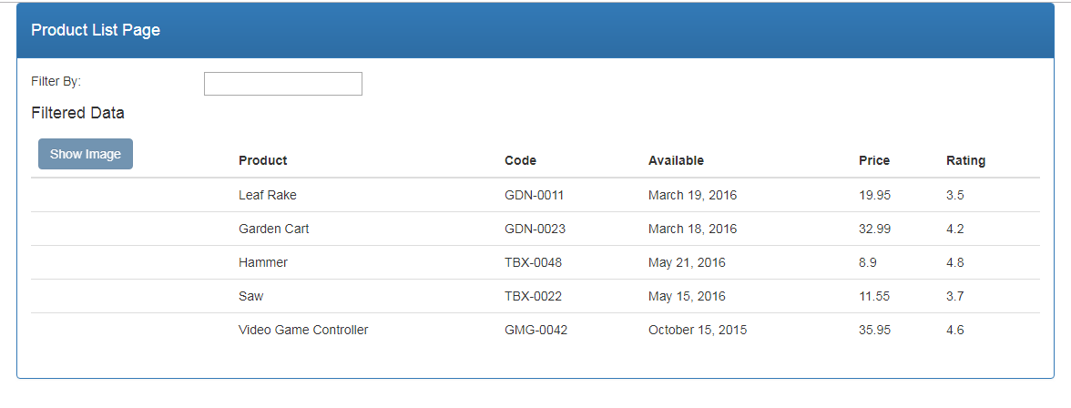

.inStock{

background: #096d09;

color:#ffff;

Font-size:15px;

}

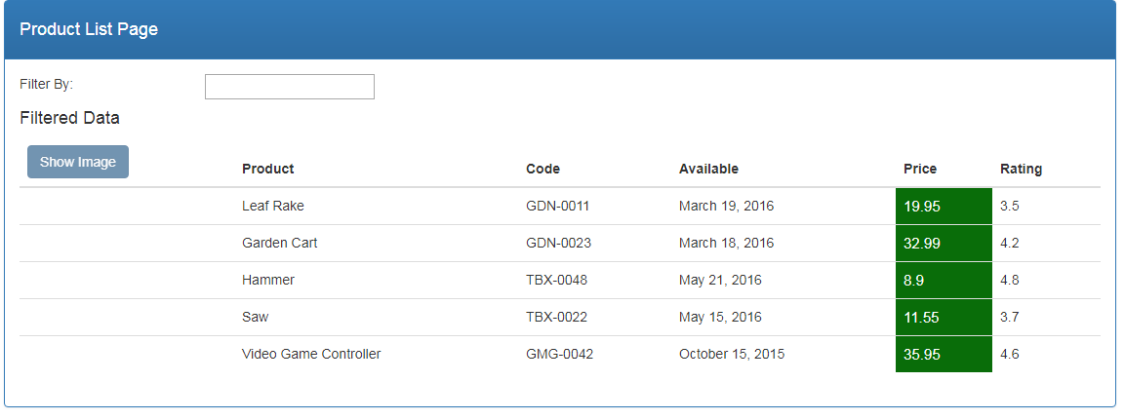

<td [class.inStock]="true">

{{ product.price}}

</td>

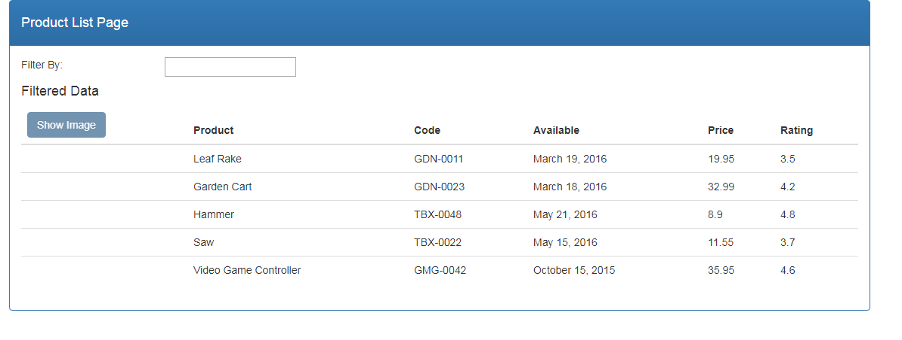

<td [style.color]="'#306A9D'" [style.font-weight]="700">

{{ product.productName }}

</td>

Output:

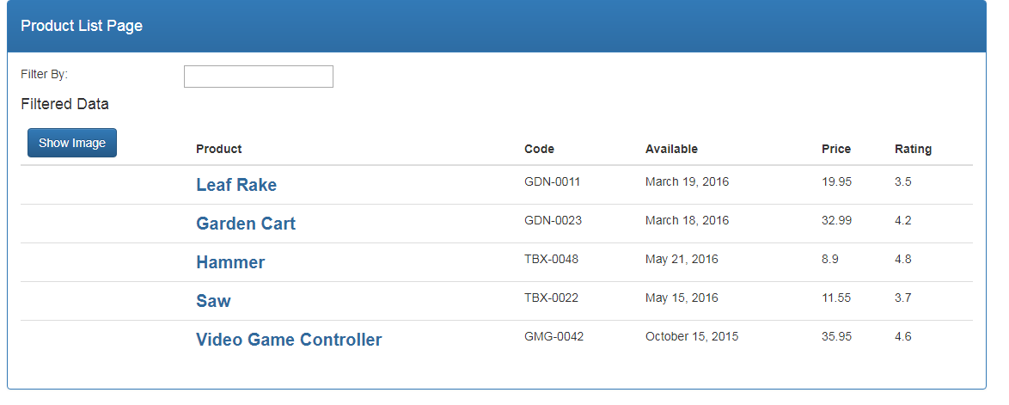

<td [style.color]="product.price > 20 ? 'red': 'green'" [style.font-size.px]="16" [style.font-weight]="700">

{{ product.price}}

</td>

Output:

